A visit to the City of North Tonawanda’s website, www.northtonawanda.org reveals there are some things on it that shouldn't be on it and some that should be on the website that aren’t.
Perhaps City Clerk-Treasurer Daniel Quinn should check out everything that is currently posted on the website and see if what I am saying isn't true.
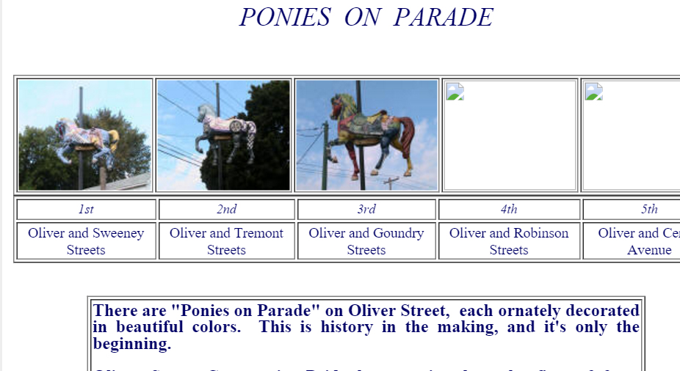
This screen shot from the NT website presents info that is outdated.
There are very stale things on it, like the “Ponies on Parade” page. Visitors to the site are given to believe the project is still ongoing, although it never got finished and died away after about five years.
The last sentence asks anyone interested in volunteering to "paint a pony" to call Linda Jufer or Kay Learned. Jufer hasn’t been at the number listed since Soos’ Oliver Street Café turned into Witter’s. Learned moved out of state. It credits Oliver Street Community Pride, which hasn’t existed in nearly ten years, as the organization presenting the pony project.
In 2011, during Mayor Rob Ortt’s tenure, a contingent from St. Peter’s United Church of Christ on Oliver came to a Common Council meeting to complain about their “missing horse”.
They said they’d paid for it years ago. They never got the “horse”. Although the page is still on www.northtonawanda.org, an attendee at the 2011 meeting described expressions on the faces of Mayor Ortt, the five Council members, City Attorney and City Clerk-Treasurer as appearing baffled. Perhaps they’d never seen the “ponies” along Oliver Street that did get mounted on their poles. They told the St. Peter’s group they’d “look into it.” Certainly, they’d never visited www.northtonawanda.org.
St. Peter’s finally got a pony up, with little fanfare.
If there hasn’t been a “Ponies on Parade” program since its first couple of years, why is it still given a lot of space on the city’s website?
There is also a page on the site about the North Tonawanda History Museum’s campaign to raise funds to move from 314 Oliver to 54 Webster. The Museum moved to Webster in 2009. Why is that page still on www.northtonawanda.org?
Instead of outdated information, how about showing NT’s parks, fees for shelter rentals, use of the gazebo, boat launching, etc.—with phone numbers. Include the Botanical Gardens, which, even in its neglected state, appears to still be popular for wedding photos.
Under Youth, Recreation & Parks, the only shelter locations listed are at Pinewoods, Mayor’s, and Klimek Veteran’s parks.
Somehow Gratwick-Riverside Park and the Botanical Gardens aren’t listed.
If you have time to spend wandering around the disorganized website, you might find them elsewhere.
Putting them all together, with shelter rental information, boat docking and launching, Deerwood Golf Course, and information on nearby dining and venues people might wish to visit while using each park would seem logical and useful.
Why not list City playgrounds, Memorial Pool and senior activities information on the website? Current and new residents would no doubt appreciate it.
Why is the Police Department listed on the main menu but not the Fire Department? Under local news, the “Metro WNY News” is listed. It changed its name a couple of years ago to the “North Tonawanda Sun.”
Why is the Downtown Historic District which was designated in 2006 by the Historic Preservation Commission not listed on the City’s website?
Somehow, notifying all property owners in the area bounded by Sweeney from Manhattan to Oliver, Manhattan from Sweeney to Goundry, Webster from Sweeney to Main, Main from Sweeney to River Road, Tremont from Manhattan to Oliver, Goundry from Manhattan to Oliver, that their property was included in a historic district was never done.
Until a current or potential property owner attempts to get a building permit to do work on the outside of their buildings, they don’t know the restrictions.
Why isn’t the Historic Preservation Ordinance on the website where current and prospective owners can become aware of its existence and what it means to them?
In any event, a professional looking website with routine maintenance which is user friendly is not what we have in North Tonawanda.
And in today’s world, a website is often the first thing a prospective visitor or future resident will see.
Judge for yourself it we are putting out best foot forward.

